**Experiment no. 7**

**Name: Sonali Dattatray Kaingade**

**PRN: 21620002**

**Title:** Find frequent itemset from given transaction data.

**Code:**

#include <bits/stdc++.h>

#include <map>

using namespace std;

double minfre;                 // Minimum frequency for itemsets to be considered frequent.

vector<set<string>> datatable; // A vector to store transaction data.

set<string> products;          // Set to store unique products/items in the transactions.

map<string, int> freq;         // A map to store the frequency of each product/item.

// Function to split a string into words based on alphanumeric characters.

vector<string> wordsof(string str)

{

    vector<string> tmpset;

    string tmp = "";

    int i = 0;

    while (str[i])

    {

        if (isalnum(str[i]))

            tmp += str[i];

        else

        {

            if (tmp.size() > 0)

                tmpset.push_back(tmp);

            tmp = "";

        }

        i++;

    }

    if (tmp.size() > 0)

        tmpset.push_back(tmp);

    return tmpset;

}

// Function to combine elements in a vector into a string, excluding the one at 'miss' index.

string combine(vector<string> &arr, int miss)

{

    string str;

    for (int i = 0; i < arr.size(); i++)

        if (i != miss)

            str += arr[i] + " ";

    str = str.substr(0, str.size() - 1);

    return str;

}

// Function to clone a set and return a copy.

set<string> cloneit(set<string> &arr)

{

    set<string> dup;

    for (set<string>::iterator it = arr.begin(); it != arr.end(); it++)

        dup.insert(*it);

    return dup;

}

// Function to generate frequent itemsets of size k based on candidate itemsets of size k-1.

set<string> apriori_gen(set<string> &sets, int k)

{

    set<string> set2;

    for (set<string>::iterator it1 = sets.begin(); it1 != sets.end(); it1++)

    {

        set<string>::iterator it2 = it1;

        it2++;

        for (; it2 != sets.end(); it2++)

        {

            vector<string> v1 = wordsof(*it1);

            vector<string> v2 = wordsof(*it2);

            // mergig v1 and v2 like lattice i.e permutations and combinations type

            bool alleq = true;

            for (int i = 0; i < k - 1 && alleq; i++)

                if (v1[i] != v2[i])

                    alleq = false;

            v1.push_back(v2[k - 1]);

            if (v1[v1.size() - 1] < v1[v1.size() - 2])

                swap(v1[v1.size() - 1], v1[v1.size() - 2]);

            for (int i = 0; i < v1.size() && alleq; i++)

            {

                string tmp = combine(v1, i);

                if (sets.find(tmp) == sets.end())

                    alleq = false;

            }

            if (alleq)

                set2.insert(combine(v1, -1));

        }

    }

    return set2;

}

int main()

{

    ifstream fin("item_set_input.csv", ios::in); // Open the input file for reading.

    if (!fin.is_open())

    {

        perror("Error in opening file : "); // Print an error message if the file cannot be opened.

    }

    cout << "Enter min Frequency  :";

    cin >> minfre; // Read the minimum frequency from the user.

    string str;

    while (!fin.eof())

    {

        getline(fin, str);

        vector<string> arr = wordsof(str);

        set<string> tmpset;

        for (int i = 0; i < arr.size(); i++)

            tmpset.insert(arr[i]);

        datatable.push_back(tmpset); // Store the transaction data in the 'datatable' vector.

        for (set<string>::iterator it = tmpset.begin(); it != tmpset.end(); it++)

        {

            products.insert(*it); // Store unique products in the 'products' set.

            freq[*it]++;          // Increment the frequency of each product in the 'freq' map.

        }

    }

    fin.close(); // Close the input file.

    cout << "No of transactions: " << datatable.size() << endl;

    // minfre = minfre * datatable.size() / 100; // Calculate the minimum frequency threshold.

    cout << "Min frequency:" << minfre << endl;

    queue<set<string>::iterator> q;

    for (set<string>::iterator it = products.begin(); it != products.end(); it++)

        if (freq[*it] < minfre)

            q.push(it);

    while (q.size() > 0)

    {

        products.erase(*q.front()); // Remove infrequent products from the 'products' set.

        q.pop();

    }

    int pass = 1;

    cout << "\nFrequent " << pass++ << " -item set : \n";

    for (set<string>::iterator it = products.begin(); it != products.end(); it++)

        cout << "{" << *it << "} " << freq[*it] << endl; // Display frequent 1-itemsets.

    int i = 2;

    set<string> prev = cloneit(products);

    while (i)

    {

        set<string> cur = apriori_gen(prev, i - 1); // Generate candidate itemsets of size 'i'.

        if (cur.size() < 1)

        {

            break;

        }

        for (set<string>::iterator it = cur.begin(); it != cur.end(); it++)

        {

            vector<string> arr = wordsof(*it);

            int tot = 0;

            for (int j = 0; j < datatable.size(); j++)

            {

                bool pres = true;

                for (int k = 0; k < arr.size() && pres; k++)

                    if (datatable[j].find(arr[k]) == datatable[j].end())

                        pres = false;

                if (pres)

                    tot++;

            }

            if (tot >= minfre)

                freq[*it] += tot;

            else

                q.push(it);

        }

        while (q.size() > 0)

        {

            cur.erase(*q.front());

            q.pop();

        }

        bool flag = true;

        for (set<string>::iterator it = cur.begin(); it != cur.end(); it++)

        {

            vector<string> arr = wordsof(*it);

            if (freq[*it] < minfre)

                flag = false;

        }

        if (cur.size() == 0)

            break;

        cout << "\n\nFrequent " << pass++ << " -item set : \n";

        for (set<string>::iterator it = cur.begin(); it != cur.end(); it++)

            cout << "{" << *it << "} " << freq[*it] << endl; // Display frequent k-itemsets.

        prev = cloneit(cur);

        i++;

    }

    ofstream fw("item_set_output.csv", ios::out); // Open an output file for writing.

    for (auto it = prev.begin(); it != prev.end(); it++)

    {

        fw << "{" << *it << "}" << endl; // Write frequent itemsets to the output file.

    }

    return 1;

}

**Result:**

**Input:**

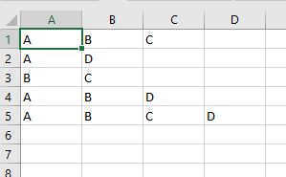

**Output:**

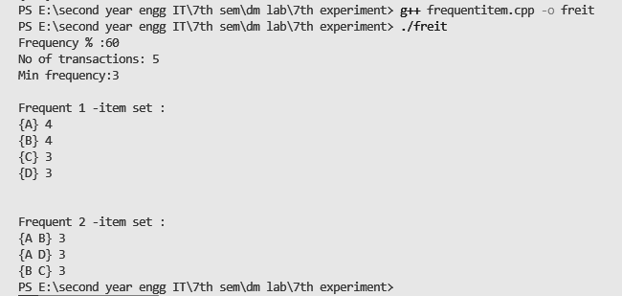

**Frequent-itemsets are:**

